**9. Kubernetes Namespaces - Limit Range – Introduction**

--- we are going to learn about limit range concept of kubernetes in relationship with namespace.

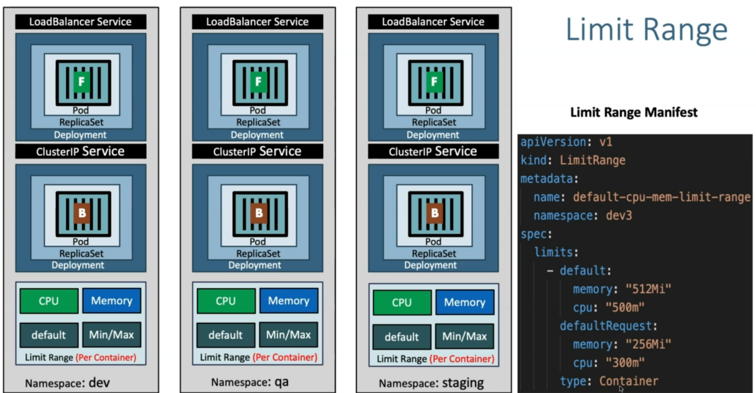

--- all the containers present inside of the dev namespace; we can limit the cpu and memory usage. Same is applied for qa, stagging and prod.

--- once you defined limit range here with cpu and memory as default so then automatically those default values get applied to the containers which are present inside of respective namespace.